**Abstract** (350 words max)

1. Intraspecific variation exists in a wide range of biological processes and is the source for species adaptation to environmental changes. Plant reproduction by seed relies on seed germination, an irreversible physiological process regulated by environmental temperature and water availability. Intraspecific variation in the thermal thresholds for germination is widespread in seed plants and has been the subject of abundant research. However, much less is known about intraspecific variation in the water thresholds for seed germination. The extent and scale of intraspecific variation in the germination base water potential (ψb i.e. the minimum amount of water required for germination) can be of high ecological significance in water-limited ecosystems, but this significance has never been tested at microclimatic scales.

2. We tested the hypothesis that water thresholds for seed germination show functional intraspecific variation along local microclimatic gradients in water-limited Mediterranean alpine ecosystems of the Iberian Peninsula (SW Europe). We sampled 18 subpopulations of the species *Dianthus langeanus* (Caryophyllaceae), separated by 10 m intervals, and with contrasting field-measured microclimatic conditions. We measured germination responses to water stress using polyethylene glycol (PEG) solutions. We fitted hydro-time models to calculate the germination ψb of each subpopulation and tested the expectation that seeds collected from warmer and drier subpopulations had lower ψb (i.e. their germination was more drought-tolerant).

3. We found significant differences between subpopulations' ψb, i.e. there was intraspecific variation in germination responses to water stress. Seeds from warmer and drier subpopulations had lower ψb, meaning their germination was more drought-tolerant. These results support that intraspecific variation in the ψb for germination has functional significance, even at environmental microscales (c. 10 m).

4. Synthesis: Our results indicate that the germination base water potential is a functional trait with important consequences for individual phenology, reproduction, and fitness in water-limited ecosystems. This functional intraspecific variation in base water potential highlights the adaptation potential of seed germination to both current and future climate scenarios.

**Key words**

Germination base water potential; Hydro-time models; Intraspecific variability; Microclimate; Microscale; Plant regeneration; Seed germination thresholds; Water-limited ecosystems.

Optional translated abstract (Spanish)

1. La variación intraespecífica es una parte imprescindible de un amplio abanico de procesos biológicos y es la base la adaptación de las especies a los cambios ambientales. La reproducción de las plantas se basa en la germinación de las semillas, un proceso fisiológico irreversible que es regulado por la temperatura y disponibilidad de agua en el ambiente. La variación intraespecífica enfocada a los límites termales para la germinación han estado objeto de abundante investigación. Sin embargo, los límites hídricos para la germinación han sido mucho menos estudiados. La distribución y magnitud de la variación intraespecífica en el potencial hídrico base para la germinación (ψb i.e. la cantidad mínima de agua requerida para germinar) puede tener un alto significado ecológico en ambientes con limitación de agua, pero su funcionalidad nunca ha sido testada en microescala.

2. En este estudio testamos la hipótesis que los límites hídricos para la germinación muestran variación intraespecífica funcional a lo largo de microgradientes locales en ambientes alpinos mediterráneos con estrés hídrico de la Península Ibérica (SW Europa). Muestreamos 18 subpoblaciones de la especie *Dianthus langeanus* (Caryophyllaceae), separadas a intervalos de 10m, y con condiciones microclimáticas contrastantes registradas en campo. Medimos las respuestas de germinación al estrés hídrico usando soluciones de polietilenglicol (PEG). Ajustamos modelos “hydro-time” para calcular ψb para la germinación en cada subpoblación y examinamos la predicción de que semillas de subpoblaciones con condiciones más cálidas y secas tendrán ψb más bajos (i.e. su germinación es más tolerante a la sequía).

3. Encontramos diferencias significativas entre los ψb de las subpoblaciones, i.e. hay variación intraespecífica en la respuesta al estrés hídrico. Semillas de subpoblaciones con condiciones más cálidas y secas tuvieron ψb más bajos, lo que significa que su germinación es más tolerante a a la sequía. Estos resultados apoyan la hipótesis que la variación intraespecífica en ψb para germinación tiene un significado funcional, incluso a microescala (aprox. 10m).

4. Síntesis. Nuestros resultados indican que el ψb para germinación es un carácter funcional con importantes consecuencias para la fenología, reproducción y fitness de los individuos en ambientes con limitada disponibilidad hídrica. Estos hallazgos resaltan el potencial de adaptación de la germinación a condiciones climáticas actuales y futuras.

## 1. Introduction

Intraspecific variation is defined as the genotypic or phenotypic differences exhibited among individuals and populations of the same species (Byars, Papst and Hoffmann, 2007; Albert *et al.*, 2010). This variation plays a key role in a wide range of biological processes, from individual fitness to population dynamics, species interactions, community assembly and ecosystem properties (Westerband et al. 2021). Intraspecific variation has been hypothesized to be a response to heterogeneous environments (Van Kleunen & Fischer 2005) and an essential condition for plants to adjust to novel environmental conditions (Jump et al. 2009). When intraspecific variation shows predictive patterns of variation along mechanistically related environmental gradients, it is understood that this variation can have a functional role in individual and population responses to the environment (de Bello *et al.*, 2021)

The plant life cycle begins with seed germination, an irreversible ecophysiological process driven by moisture and temperature (Bewley et al. 2013). In seasonal climates, successful regeneration is limited to a specific timeframe, where germination responses to moisture and temperature serve to match germination to this timeframe (Anderson et al. 2012, Escobar et al. 2018, Rosbakh et al. 2022). At the same time, this dependency on moisture and temperature means that germination can be highly sensitive to changes in these two environmental factors (Walck *et al.*, 2011). Thus, the adaptation or acclimatization of plant regeneration to ongoing climate change will largely depend on intraspecific variation in seed germination responses to moisture and temperature (Cochrane *et al.*, 2015). However, compared to temperature (Orrù *et al.*, 2012; Fernández-Pascual *et al.*, 2013; Fernández-Pascual, Mattana and Pritchard, 2019), there are fewer studies on how the germination of wild species responds to changes in environmental moisture or water stress (Bernau *et al.*, 2020; Sumner and Venn, 2021). Current assumptions about germination responses to drought are centred on the species level (Kos and Poschlod, 2008; Yi *et al.*, 2019; Gelviz-Gelvez *et al.*, 2020), and the extent of intraspecific variation in germination responses to water stress is largely unknown (Gya *et al.*, 2023). Furthermore, it is unknown if this variation has functional significance (de Bello *et al.*, 2021).

A potential functional role for intraspecific variation in germination responses to water availability could be to match germination with water-available periods, thus maximising the favourable period for seedling establishment (Escobar, Silveira and Morellato, 2018). Optimizing the timing of germination in a water-limited system could increase the time for development of a root system capable of surviving summer drought, having a direct effect on seedling survival and overall plant fitness (Giménez-Benavides, Escudero and Iriondo, 2007). Recent findings support that within a single species, populations from arid conditions show advanced reproductive phenology: earlier flowering (Anderson *et al.*, 2012), germination (Christie *et al.*, 2022; Mira *et al.*, 2023) and seedling emergence (Dickman *et al.*, 2019). Such intraspecific variation in phenological and reproductive allocation traits is key for climate adaptation (Kurze, Bareither and Metz, 2017) (Anderson *et al.*, 2012). For example, results from (Dickman *et al.*, 2019) show rapid shifts in regeneration trait means and variance in response to drought, increasing the chance of population survival.

In alpine ecosystems (i.e. areas above the treeline, Körner, 2021), current climate change is producing earlier snowmelt (Vorkauf *et al.*, 2021) and increasing summer drought (Kotlarski *et al.*, 2023). However, the high topographic complexity (Scherrer and Körner, 2011) of alpine systems creates microclimatic gradients that could buffer the effect of climate warming in alpine communities (Körner and Hiltbrunner, 2021; Jiménez- Alfaro, Fernandez-Pascual and Espinosa Del Alba, ClaraMarcenó, 2024). Because of these same microclimatic gradients, it can be expected that alpine plants show intraspecific variation in their seed regeneration traits. This variation may be especially critical in alpine systems influenced by Mediterranean climatic conditions, which can be water-limited by a period of 1-2 months of summer drought (Sumner and Venn, 2021).

A promising approach to study seed responses to moisture and water stress is the application of developmental threshold models (Donohue *et al.*, 2015), specifically, the modelling of the seed germination niche using hydro-time models (Allen, Meyer and Khan, 2000; Bradford, 2002; Bewley *et al.*, 2013). In the hydro-time framework, for germination to happen, water availability in the environment must surpass a specific threshold (i.e. the base water potential, ψb). Each seed in a population has its own value of ψb, and therefore calculating this parameter and its variation allows to test the sources and mechanisms of variation among individuals (i.e. the intraspecific variation in seed responses to water stress) (Donohue *et al.*, 2015). In this study, we used hydro-time models to measure the intraspecific variation of germination responses to water stress along a microclimatic gradient in a drought-limited Mediterranean alpine ecosystem. We focused on an endemic and locally abundant species adapted to these conditions, *Dianthus langeanus* Wilk. (Caryophyllaceae). Our hypothesis was that germination responses to water stress would show functional intraspecific variation along local gradients of water availability. In particular, we expected lower ψb for germination in seeds collected from warmer and drier subpopulations (i.e. germination more drought-tolerant).

## 2. Material and Methods

### 2.1. Study system

*Dianthus langeanus* Wilk. (Caryophyllaceae) is a wild carnation endemic to the mountain systems of the northwestern Iberian Peninsula (Fig. 1A). *D. langeanus* mainly lives in open dry grasslands on acid soils (Fig. 1B), where it can be locally abundant. Flowering onset occurs in early June and ripe seeds are dispersed during August (Fig. 1C). Seed production is high, usually > 10 seeds per capsule and up to 250 seeds per individual. Germination occurs mainly during end-summer/early autumn at high rates and with high success when water is available at temperatures between 10 and 22 °C. Here, we studied wild populations of *D. langeanus* in the northern limit of its distribution, in the Valles de Omaña and Luna Biosphere Reserve, in the southern Cantabrian Mountains (Fig. 1A). The Cantabrian Mountains run E-W in northern Spain along 480 km in parallel to the Cantabrian Sea. This mountain system includes summits above 2500 m a.s.l. and the treeline in acid soil climbs up to 1650 m a.s.l. (González Le Barbier et al., 2024, under revision). It is a transitional biogeographical hub between the Eurosiberian and Mediterranean regions (Jiménez-Alfaro *et al.*, 2021), influenced by the Mediterranean climate on the southern slopes and the oceanic temperate climate on the northern slopes.

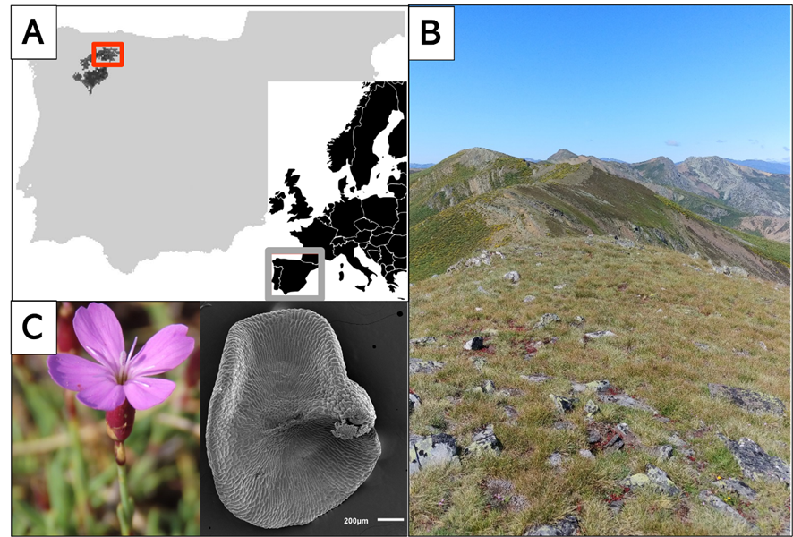

**Figure 1.** Study system. (A) Distribution of Dianthus langeanus in the Iberian Peninsula (dark areas, adapted from Rocha et al., 2017); the red square highlights our study system. (B) One studied community with D. langeanus in Mediterranean alpine acidic grasslands of Sierra de Villabandín, Cantabrian Mountains, Spain. (C) Detail of D. langeanus flowers and seeds.

### 2.2. Field sampling

We established a systematic sampling across four nearby summits above 2000 m a.s.l. (Fig. 2) where *D. langeanus* is highly abundant. In each summit, we established a central representative plot (3 m radius) where we did a floristic relevé, recording species composition; and buried, at 5 cm deep, a Microlog SP3 datalogger, with hourly records of soil temperature and soil water potential (MicroLog SP3, EMS Brno, Czech Republic; accuracy in temperature measurements: +/- 0.3 °C from -40 °C to 60 °C; water potential measurements with two Delmhorst gypsum sensors measuring range from -0.1 to -15 bars – permanent wilting point; records every hour). The recording period for the Microlog SP3 went from June 2021 to November 2023 (raw data available in GitHub repository). To measure the spatial microenvironmental gradients we established 20 additional plots (1m2) per each summit: five plots in each cardinal direction with a 10 m separation (cross design, Fig. 2, Jiménez- Alfaro et al. 2024). We also sampled species composition in these plots and buried, at 5 cm deep, iButton dataloggers (Thermochron, iButton, Newbury, UK; accuracy: +/- 0.5 °C from -10 °C to +65 °C, resolution: 0.5 °C, records every four hours). The recording period for the iButtons went from 12th July 2021 to 29th May 2022 (321 days, raw data available in GitHub repository). In total, we collected floristic data from 84 plots and environmental data from 78 plots (one MicroLog SP3 was damaged, and five iButtons could not be recovered).

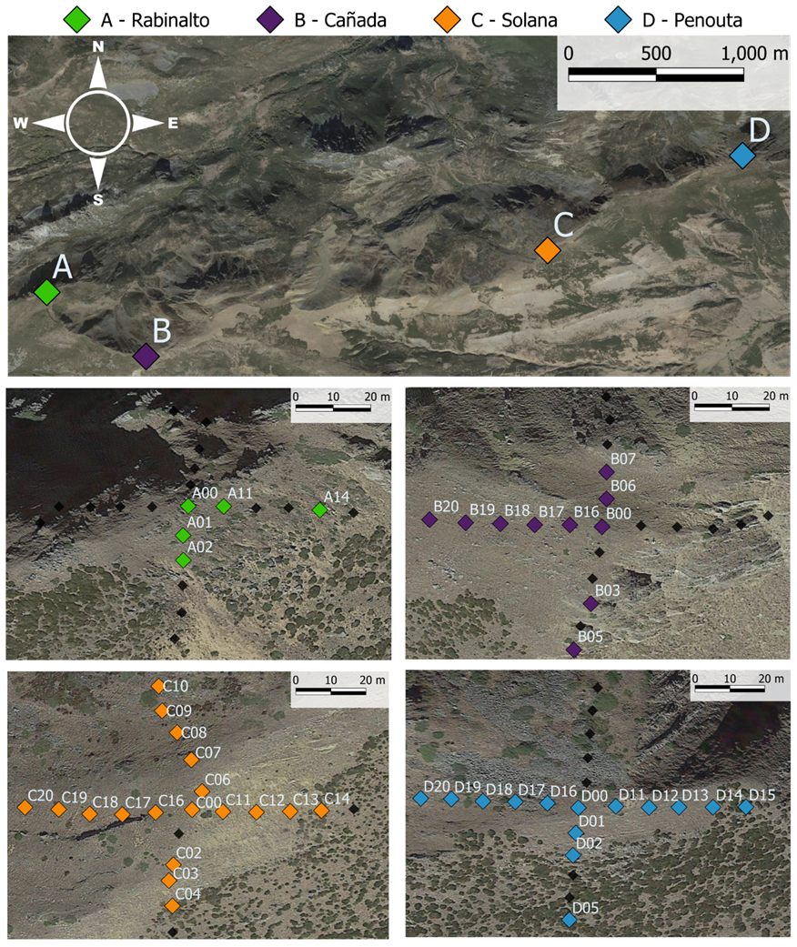

**Figure 2**. Field sites. Upper panel: Location of the four summits included in our study. Lower panels: Aerial image of our sampling cross design in each of the four summits. In each diamond, we registered floristic relevés, buried environmental data loggers and collected *Dianthus langeanus* seeds when available. Coloured squares represent subpopulations where *D. langeanus* was present; black squares sites where *D. langeanus* was absent.

*D. langeanus* was present in 47 out of 84 plots (Fig. 2). In the plots where *D. langeanus* was present, local community richness ranged from 3 to 14 species (average of 8 species). The communities with *D. langeanus* were dominated by the graminoid hemicryptophytes *Festuca summilusitana* Franco and Rocha Afonso (Poaceae) and *Luzula caespitosa* J. Gay ex E. Mey. Steud (Juncaceae). The most frequent accompanying species were *Sedum brevifolium* DC, *Neoschischkinia truncatula* subsp. *durieui* Boiss. & Reut. ex Willk. Valdés & H.Scholz and *Armeria duriaei* Boiss.

Soil climate was typically Mediterranean, with a 2-month drought period in summer (Fig. 3A). The growing season stretched from end of March to November with a mean annual soil temperature of 8 °C. Monthly maximum and minimum soil temperatures reached up to 40 °C in summer and went down to -4 °C in winter (Fig. 3A).

**Figure 3**. Climate of the study sites. (A) Climatic diagram of our study area, based on Microlog SP3 data from July 2021 to June 2022 from three of the four investigated summits. Lines in red represent monthly averages of the daily maximum and minimum temperatures (left y-axis); bars in grey represent the monthly averages of the maximum water stress in MPa (right y-axis). (B) Positive correlation between GDD and cumulative water stress (ΣΨ) in different years at each site. We used data from the growing season (April-November) of 2022 and 2023 in three of our summits, Cañada data is not complete and thus was removed from the visualization. (C) Principal Component Analysis ordination of the microclimatic indices for the 78 plots with environmental data. Each colour represents plots from a different summit.

### 2.3. Microclimatic indices

We used the records of our dataloggers to calculate soil microclimatic indices as in Jiménez- Alfaro et al. (2024). First, we homogenized the data between the two data loggers (MicroLog SP3 and iButtons) by keeping the same recording frequency (every four hours) and the same time period with records for all loggers (the 321 calendar days from 12th July 2021 to 29th May 2022). We calculated bioclimatic indices based on WorldClim standard bioclimatic variables (Fick & Hijmans 2017), together with other variables relevant for describing alpine micro topographical gradients. We selected six temperature-related indices: (1) bio1 = annual mean temperature; (2) bio2 = mean diurnal range, i.e. the mean of the monthly differences between maximum and minimum temperatures; (3) bio7 = temperature annual range; i.e. the difference between the maximum temperature of the warmest month and the minimum temperature of the coldest month; (4) snow = the number of days of snow cover, when the soil temperature is around 0 °C, calculated for the period in which the maximum temperature was < 0.5 °C and the minimum temperature was > -0.5 °C; (5) FDD = freezing degree days, i.e. the sum of daily mean temperatures for days in which the mean temperature was below 0 °C (Choler 2018); and (6) GDD = growing degree days, i.e. the sum of daily mean temperatures for days in which the soil mean temperature at five cm deep was above 5 °C (Körner 2021). For easier interpretation of FDD, we transformed the values from negative to positive, so higher values represent more freezing conditions (Supplementary Table 1).

Some studies that have approached the interrelationship between temperature and water availability in the soil showed that drier soils also become warmer (Seneviratne *et al.*, 2010), however to our knowledge very few has been done at a microscale level (Graham *et al.*, 2012). Therefore, we used Microlog SP3 data collected for seven subpopulations in 2022 and 2023 to test using a linear model if, as expected, there was a positive relationship between GDD and cumulative water potential i.e. warmer years are also drier years at local scale. The significant results (R2 = 0.69, P < 0.01, Fig. 3B) were used to confidently extrapolate this assumption to all subpopulations sampled. See the discussion for further considerations about this assumption.

To identify the main gradients of microclimatic variation, we conducted a principal component analysis (PCA) including all bioclimatic indices (Fig. 3C). Axis 1 of the PCA explained 64% of the variance and ordered the 78 plots along a gradient of thermicity, towards which the greatest contribution was made by GDD (23.4) and bio1 (23.5). GDD was highly correlated with bio1, bio2, bio7 and FDD (> 70 %, details in Supplementary Table 2). Therefore, we decided to use GDD as the single best descriptor of microclimatic variation for further analyses.

### 2.4. Seed collection

We sampled seeds of *D. langeanus* from each plot where the species was present (Fig. 2). We collected mature fruits (capsules) at the time of natural dispersal (August 7 - 8th, 2023). In each plot, we sampled at least 20 randomly selected mother plants within a 2 m radius from the datalogger, following standard protocols for sampling seeds of wild populations (ENSCONET, 2009). In total, we sampled 47 plots with *D. langeanus* but only were able to collect enough seeds for experiments (> 600 seeds) from 18 of them, hereafter called “subpopulations”. Immediately after collection, we manually cleaned the seeds and kept them at room conditions (22 °C and 35 % RH) until the start of the germination experiments. For each subpopulation used in subsequent experiments, we measured dry seed mass by weighing 10 individual seeds from each subpopulation after the seeds had spent three months drying with silica gel (Mettler Toledo, New classic SG – Model ML1052E/01, precision 0.1 mg).

### 2.5. Germination experiments

We wanted to measure germination responses to water stress in significant ecological conditions, i.e. using fresh seeds at the time of dispersal. At the same time, based on previous information on Mediterranean alpine species (Mattana *et al.*, 2022), we expected that fresh *D. langeanus* seeds could show some degree level of physiological dormancy and that they could require dry after-ripening to release this dormancy. Since we wanted to calculate hydro-time models (Bradford, 2002) using non-dormant seeds and no prior information about dormancy alleviation was available for our study species; we repeated the experiments with two seed storage treatments to ensure working with non-dormant but relatively fresh seed lots: fresh seeds (10 days after collection, hereafter called “fresh”) and after ripened seeds (45 days after collection, hereafter called “after ripened”). For each storage treatment, we used 12 subpopulations, as seed numbers allowed: six subpopulations were repeated for both treatments, six subpopulations were used only for the fresh treatment, and six subpopulations were used only for the after ripened treatment (Table 2).

To test the seed germination responses to water stress, we performed laboratory experiments using polyethylene glycol (PEG, an inert water-binding polymer) solutions to simulate different water potential scenarios. PEG solutions maintain relatively steady and precise osmotic potentials to study germination water thresholds (Bewley *et al.*, 2013). Since we could not find previous information about the species water potential requirements for germination, we performed a pilot study that showed zero germination at -1.4 and -1.6 MPa. Thus, we excluded those levels and selected seven water potential treatments for the final experiment: 0, −0.2, −0.4, −0.6, −0.8, −1 and −1.2 MPa. For each treatment combination (7 water potential treatments x 2 storage treatments x 12 subpopulations) we sowed four Petri dishes with 25 seeds each (except in the -1 and -1.2 MPa water potential treatments, where we expected low germination, and we sowed only two dishes with 25 seeds each). We used 90 mm Ø Petri dishes with two layers of filter paper (Filtros Anoia S.A. paper for germination assays, Ref. 518G085). To each dish, we added five ml of either (a) distilled water or (b) a PEG 6000 solution prepared according to Michel & Kaufmann (1973) and Villela et al. (1991) to reach desired osmotic potentials at 20 °C (the experimental temperature). We sealed Petri dishes with parafilm to avoid evaporation of the solutions and to maintain constant water potentials throughout the experiment.

Seeds were incubated in conditions simulating late summer days in the field when germination has been described to happen in a previous exploratory experiment (not shown): constant 20 °C with a daily photoperiod of 12-12h light/dark. It must be noted that we used constant 20 °C rather than a more realistic diurnal alternating regime to maintain the stability of water stress conditions for the PEG solutions. Conditions were programmed in an incubator (Aralab climatic chamber Fitoclima S600 PL, equipped with four led modules 11W 350mA). We monitored germination, defined as radicle emergence > 1.5 mm, for 28 days: daily until the cumulative germination curve flattened (day 21) and then every two or three days until the end of the experiment. We removed germinated seeds during the scoring and, once the experiments were finished, we cut non-germinated seeds under a binocular loupe and classified them as viable, dead, or empty. Seeds with firm and white embryos were considered viable, i.e. potentially germinable (Baskin and Baskin, 2014). Subsequent analyses only consider germinated and germinable seeds. A total of 14,246 viable (germinated + germinable) *D. langeanus* seeds were used in this study (raw data is available in GitHub repository).

**Table 1.** Replication statement

|  |  |  |
| --- | --- | --- |
| **Scale of inference** | **Scale at which the factor of interest is applied** | **Number of replicates at the appropriate scale** |
| Subpopulation | Seed | 25 seeds x 4 Petri dish x 2 storage treatments x 12 subpopulations  25 seeds x 4 Petri dish x 7 Water Potential treatments x 18 subpopulations |

### 2.6. Data analysis

### All analyses were done in R (R Core Team, 2022) using the packages glmmTMB (Brooks *et al.*, 2017) for fitting Generalized Linear Mixed Models (GLMMs) and seedr (Fernández-Pascual and González-Rodríguez, 2020) for fitting hydro-time models. Model fit and residuals were visually checked using the DHARMa package (Hartig, 2020). Data visualization was created with packages ggplot2 (Wickham, 2016) and patchwork (Pedersen, 2023) with the wesanderson palette (Ram and Wickham, 2023).

### To explore the dormancy levels of the seeds, i.e., whether final germination varied as a function of storage time and water potential, we fitted GLMMs with binomial distribution, in which germination proportion was the response variable. Explanatory fixed factors were the storage and water potential treatments. Random factors included subpopulation nested within summit in the model formula: Final germination (germinated, viable - germinated) ~ storage * water potential + (1|summit/subpopulation), family = binomial.

To test our primary prediction, i.e., whether ψb varied as a function of subpopulation microclimate, we calculated the water potential germination thresholds of each subpopulation by fitting hydro-time models with the seedr package. For each subpopulation, the model returned the base water potential (ψb), i.e. the lower water potential threshold beyond which no germination is possible. Then, we modelled ψb as a function of the subpopulation’s microclimate (measured as GDD, see above) using GLMMs with Gaussian distribution. Explanatory fixed factors were the storage treatment and the subpopulation’s specific GDD. The summit was included as a random factor (and not subpopulation, as before, since in this case each subpopulation provided one data point for the model) in the model formula: ψb ~ storage * GDD + (1|summit), family = Gaussian. We found a significant interaction storage * GDD, consequently, we tested each storage treatment separately to check if ψb varied according to GDD in fresh vs. after ripened seeds. Model formula: ψb ~ GDD + (1|summit), family = Gaussian.

Additionally, we wanted to control for seed mass, a trait that can modulate germination responses (Bond, Honig and Maze, 1999; Pons and Fenner, 2000; Fernández-Pascual, Mattana and Pritchard, 2019; Fernández-Pascual *et al.*, 2021). Evidences on germination responses to drought controlling by seed mass are contradictory with both positive responses for smallest seeds (Kikuzawa and Koyama, 1999; Merino-Martín *et al.*, 2017; Gya *et al.*, 2023) and also positive responses to largest seeds (Kidson and Westoby, 2000; Gelviz-Gelvez *et al.*, 2020). We checked if germination ψb varied as a function of seed mass by fitting GLMMs with gamma distribution (since the model did not fulfil Gaussian assumptions). However, we found no significant relationship between seed mass and germination ψb.

## 3. Results

Our results confirmed that fresh seeds (i.e. 10 days after collection) had some degree of dormancy. Final germination was higher in after ripened than in fresh seeds (Fig. 4A). With no water stress (i.e. distilled water treatment, WP treatment = 0) fresh seeds only attained around 70% germination, while germination of after ripened seeds was almost 100%. With increasing water stress, germination dropped below 50% at -0.2 MPa in fresh seeds, whereas, in after ripened seeds, water stress needed to reach -0.6 MPa to cross the same germination threshold. At -0.8 MPa and below, germination was negligible in both fresh and after ripened seeds. Lower water potential also led to slower germination (Fig. 4B, see supplementary Fig 1 for subpopulation-level cumulative germination curves). GLMMs confirmed significant effects of storage, water potential treatments and their interaction (p < 0.001, see supplementary Table 3 for full model details).

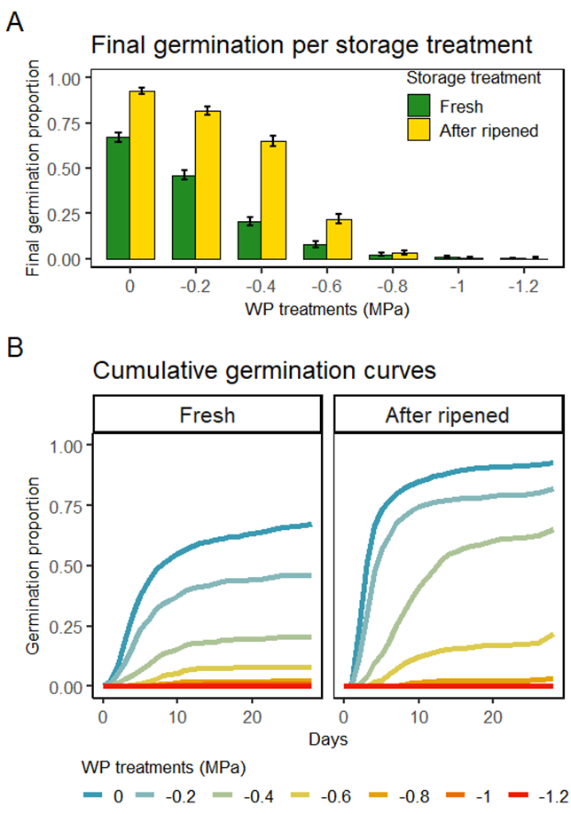

**Figure 4**. Germination responses to water stress in fresh (i.e. dormant) and after-ripened (i.e. non-dormant) seeds. Figures show the values averaged across all subpopulations (n = 12). (A) Mean final germination proportions and binomial confidence intervals in both storage treatments and every water potential treatment. (B) Cumulative germination curves in both storage treatments and every water potential treatment.

We used Bradford’s hydro-time model to calculate the ψb for germination in the 12 subpopulations of the fresh treatment, and in the 12 populations of the after ripened treatment (Table 2). Values of ψb were higher (i.e. less water stress-tolerant) in the fresh than in the after ripened seeds (average -0.1 vs -0.4 in those six subpopulations that were sown at both storage times) (Table 2).

**Table 2**. Bradford hydro-time model results for the studied subpopulations in fresh and after-ripened conditions. The detailed location of subpopulation codes is shown in Figure 2. N treatments = number of water potential treatments that could be included in the model; theta = hydro-time constant; ψb = Base water potential (median); sigma = sigma of the base water potential; R2 = adjustment of the model.

|  |  |  |  |  |  |  |  |  |  |  |
| --- | --- | --- | --- | --- | --- | --- | --- | --- | --- | --- |
|  | Fresh | | | | | After ripened | | | | |
| Subpopulation | N treatments | theta | ψb | sigma | R2 | N treatments | theta | ψb | sigma | R2 |
| A00 | 7 | 0.73 | 0.04 | 0.47 | 0.81 | 4 | 1.03 | -0.40 | 0.17 | 0.97 |
| A02 |  |  |  |  |  | 5 | 1.50 | -0.55 | 0.24 | 0.96 |
| A11 |  |  |  |  |  | 5 | 1.18 | -0.44 | 0.27 | 0.98 |
| B00 | 6 | 0.95 | -0.06 | 0.41 | 0.88 |  |  |  |  |  |
| B03 | 6 | 1.26 | 0.08 | 0.57 | 0.89 | 5 | 1.46 | -0.47 | 0.25 | 0.95 |
| B07 | 5 | 0.78 | 0.07 | 0.41 | 0.88 |  |  |  |  |  |
| B17 | 6 | 1.26 | -0.10 | 0.45 | 0.91 |  |  |  |  |  |
| B19 |  |  |  |  |  | 4 | 1.09 | -0.35 | 0.25 | 0.96 |
| B20 | 4 | 0.67 | -0.16 | 0.28 | 0.90 |  |  |  |  |  |
| C00 | 6 | 0.87 | -0.17 | 0.32 | 0.90 | 5 | 1.14 | -0.43 | 0.22 | 0.95 |
| C06 | 5 | 0.92 | -0.25 | 0.34 | 0.94 |  |  |  |  |  |
| C18 |  |  |  |  |  | 5 | 1.09 | -0.37 | 0.24 | 0.95 |
| C19 | 6 | 0.70 | -0.17 | 0.38 | 0.91 | 6 | 0.92 | -0.41 | 0.24 | 0.94 |
| C20 |  |  |  |  |  | 5 | 1.20 | -0.44 | 0.23 | 0.94 |
| D00 | 5 | 0.92 | -0.23 | 0.32 | 0.91 | 5 | 1.01 | -0.45 | 0.21 | 0.93 |
| D11 |  |  |  |  |  | 5 | 1.54 | -0.48 | 0.30 | 0.90 |
| D12 | 5 | 0.77 | -0.13 | 0.31 | 0.88 |  |  |  |  |  |
| D19 | 5 | 0.94 | -0.16 | 0.35 | 0.93 | 5 | 1.29 | -0.42 | 0.28 | 0.91 |

Given the significant interaction between storage treatment and microclimate (measured as GDD; model z = 2.45, *p* < 0.05), we analysed the relationship between ψb and GDD separately for fresh and after ripened seeds. For fresh seeds we found no significant relationship (Fig. 5 left panel). On the contrary, after ripened seeds showed a significant relationship (z = -1.99, *p* <0.05) of decreasing ψb in subpopulations with higher GDD, i.e. more water-stress tolerance in subpopulations from drier and warmer plots, as per our primary prediction (Fig. 5, right panel) (detailed model results in supplementary Table 4).

**Figure 5**. Seed germination ψb as a function of microclimatic conditions. Results are shown separately for fresh (i.e. dormant) and after-ripened (i.e. non-dormant) seeds (n = 12, subpopulations in each storage treatment). Germination ψb was calculated using the hydro-time model. Microclimate was measured as growing degree days (GDD) above 5 °C. P-values obtained from GLMMs as explained in the methods.

### 4. Discussion

Our study confirms that subpopulations of *D. langeanus* in warmer and drier conditions have lower ψb for germination, indicating that germination responses to water stress show intraspecific variation along local microclimatic gradients of water availability. Although intraspecific trait variation has been previously stated to be strongly driven by microenvironmental heterogeneity (Westerband, Funk and Barton, 2021), this is the first time that within-population variation at the microscale level has been reported for regeneration traits. The fact that this variation aligns with a gradient of water stress supports that ψb is a functional trait with important consequences for individual fitness and species occurrence patterns at the local scale.

The higher germination we observed in after ripened seeds across all water potential treatments supports that a low level of dormancy in fresh *D. langeanus* seeds is alleviated by a short period of after-ripening (35 days). Seeds drastically changed their germination responses in a month, suggesting notable ecological implications of rainfall timing (Levine, Mceachern and Cowan, 2011) in alpine water-limited environments. If rain episodes occur concurrently with dispersal, or shortly thereafter, the dormant part of the seed population will fail to germinate despite the moistened soils and favourable temperatures. Our results indicate a type of developmental delay (Tuljapurkar, 1990; Tuljapurkar and Wiener, 2000) which has been interpreted as a type of bet-hedging in face of unpredictable disturbances (Venable and Brown, 1988; Gremer and Venable, 2014), such as potential dry-autumn years that could result in high seedling mortality. Bet-hedging has been observed in other habitats with high climate variation and found advantageous during drought events (Evans and Dennehy, 2014; Lampei, Metz and Tielbörger, 2017). If rain episodes happen a month after dispersal, when drought risk can be predicted to be lower due to the closeness of winter, most of the seed population will be able to germinate, and to respond appropriately to microscale soil water stress. These results highlight how a short after ripening period can have a major functional impact in seeds regeneration in the field.

The functional significance of ψb (and after-ripening) demonstrates the importance of drought in driving the timing and success of germination in water-limited ecosystems. This is also the case in alpine systems, highlighting the importance of alpine drought, a factor which has been generally ignored in previous alpine research and which is expected to become more incident in the future (Kotlarski *et al.*, 2023), especially in biogeographically transitional mountains such as the southern European mountain systems. Unexpectedly, the ψb for germination in *D. langeanus* (average across after-ripened populations = -0.48 MPa)is relatively high in comparison to some other species (i.e. germination tolerance to water stress seems relatively low). Our results *D. langeanus* are comparable to studies performed with temperate floras (e.g., Britain) in which a sharp decrease of germination was reported under water potentials between -0.57 and -0.7 MPa (Evans and Etherington, 1991). However, our values contrast with lower ψb reported for Mediterranean ruderal species (e.g., -0.8 to -1.9, Frischie et al. 2018; Jiménez-Alfaro et al. 2018), perhaps because our study system is less limited by water than typical low-altitude Mediterranean systems. Alternatively, the relatively high ψb of *D. langeanus* could be a way to ensure that germination only goes forward with intense rainfall episodes, i.e. a best-bet strategy to match germination to the most favourable environmental window (Pausas *et al.*, 2022).

The lower ψb (i.e. more drought tolerance) observed in warmer and drier microclimatic conditions suggests either a potential local adaptation or a wide phenotypic plasticity at the microscale. However, we note that our experimental design does not allow to disentangle both processes and future reciprocal and common garden experiments are needed (e.g., Potvin & Tousignant 1996). Nevertheless, it is clear that the intraspecific variation detected in our study area does not follow a random pattern, i.e. it has functional significance. This is in line with several studies in alpine areas which suggest that local adaptation processes are taking place in the seed regeneration niche (Giménez-Benavides, Escudero and Iriondo, 2007; Mondoni *et al.*, 2009). The persistence of plant populations is shaped by a dynamic and complex feedback between phenotypic plasticity and local adaptation (Kinnison and Hairston, 2007), both processes aimed at adjusting to new environmental conditions (Nicotra *et al.*, 2010; Reed, Schindler and Waples, 2011; Fernández-Pascual and Jiménez-Alfaro, 2014). Our results are also in line with previous studies that showed adaptive evolution of phenotypic plasticity in nature, even at small spatial scales (Van Kleunen and Fischer, 2005). Under climate change scenarios, phenotypic plasticity may be the key to accelerate plant responses to new conditions (Matesanz, Gianoli and Valladares, 2010; Nicotra *et al.*, 2010; Reed, Schindler and Waples, 2011; Walck *et al.*, 2011), acting as a buffer against environmental changes (Lande, 2009; Chevin, Lande and Mace, 2010) and showing adaptive responses to drought within a few years (Dickman *et al.*, 2019).

Although our study supports the functional significance of germination water potential as a relevant seed trait, we must acknowledge some caveats to our conclusions. First, our environmental data is constrained to 2021- 2022 while seeds were collected in 2023. Therefore, we must assume that relative microclimatic differences between subpopulations remain comparable across years, and that our GDD measures are a valuable proxy for the environmental drought gradient, which is not unreasonable since in the study system soil climate largely depend on stable factors such as slope, exposure and soil physical properties. Temperature influences soil moisture through several coupled pathways, generating an increment of evapotranspiration rates (i.e. higher moisture loss) but also reducing the amount of snow and snow-related water supply in the soil (Seneviratne *et al.*, 2010). This relationship of heat and drought has been corroborated at larger scales (Seneviratne *et al.*, 2010) but very few studies have tested it at local scales (Graham *et al.*, 2012). Second, the constant germination temperatures used in the experiments are not realistic in field conditions, but they were necessary to maintain the stability of water potential solutions. Moreover, our preliminary data indicated that the focus species has a wide germination niche without significant differences between constant and alternating temperatures, reaching up to 70% germination even in darkness. Third, the translation of laboratory PEG results into field behaviour should be done carefully (Camacho *et al.*, 2021). In the field, soil water availability is affected by dynamic soil hydraulic conductivity, which in turn depends on soil textural properties (Camacho *et al.*, 2021). It would be important to confirm our results with field emergence data, but it must be considered that maintaining such controlled water potential treatments in the field would be extremely difficult if not impossible with current technology.

Future research should extend our understanding of intraspecific variation in germination responses to water stress to other species and ecosystems, including different degrees of environmental water-limitation. In addition, complementary studies with reciprocal sows and common garden experiments will help to disentangle the effects of phenological plasticity and local adaptation. Finally, our understanding needs to be expanded to include the whole seed regeneration spectrum, including soil seed persistence and seedling emergence responses to microclimatic conditions under current and future scenarios.

Be that as it may, ψb is a functional trait with important consequences for reproductive timing and success and, ultimately, for individual fitness. The fact that it shows intraspecific variation along microscale climatic gradients of water availability indicates that seed germination has a high potential to adapt to climatic changes, highlighting the capacity of seeds to integrate environmental signals to produce a fine scale regulation of germination events in time and in space. This capacity can be a valuable buffer against global change effects. In particular, it can help plant populations to cope with the increasing unpredictability of precipitation in future climatic scenarios.

## 5. References

Albert, C. H. *et al.* (2010) ‘Intraspecific functional variability: Extent, structure and sources of variation’, *Journal of Ecology*, 98(3), pp. 604–613. doi: 10.1111/j.1365-2745.2010.01651.x.

Allen, P. S., Meyer, S. E. and Khan, M. A. (2000) ‘Hydrothermal time as a tool in comparative germination studies.’, *Seed biology: advances and applications. Proceedings of the Sixth International Workshop on Seeds, Merida, Mexico, 1999.*, (January), pp. 401–410. doi: 10.1079/9780851994048.0401.

Anderson, J. T. *et al.* (2012) ‘Phenotypic plasticity and adaptive evolution contribute to advancing flowering phenology in response to climate change’, *Proceedings of the Royal Society B: Biological Sciences*, 279(1743), pp. 3843–3852. doi: 10.1098/rspb.2012.1051.

Baskin, C. C. and Baskin, J. M. (2014) *Seeds. Ecology, Biogeography and Evolution of Dormancy and Germination*. 2nd Editio, *Seeds*. 2nd Editio. San Diego, CA, USA: Academic Press. doi: 10.1016/B978-0-12-416677-6.00001-9.

de Bello, F. *et al.* (2021) ‘Intraspecific Trait Variability’, in *Handbook of Trait-Based Ecology: From Theory to R Tools*. Cambridge University Press, pp. 105–128.

Bernau, V. M. *et al.* (2020) ‘Germination response of diverse wild and landrace chile peppers (Capsicum spp.) under drought stress simulated with polyethylene glycol’, *PLoS ONE*, 15(11 November), pp. 1–19. doi: 10.1371/journal.pone.0236001.

Bewley, J. *et al.* (2013) ‘Environmental regulation of dormancy and germination’, in Bewley, J., Bradford, K, and Hilhorst, H (eds) *Seeds: physiology of development, germination and dormancy*. 3rd edn. New York: Springer.

Bond, W. J., Honig, M. and Maze, K. E. (1999) ‘Seed size and seedling emergence: An allometric relationship and some ecological implications’, *Oecologia*, 120(1), pp. 132–136. doi: 10.1007/s004420050841.

Bradford, K. J. (2002) ‘Applications of hydrothermal time to quantifying and modeling seed germination and dormancy’, *Weed Science*, 50(2), pp. 248–260. doi: 10.1614/0043-1745(2002)050[0248:aohttq]2.0.co;2.

Brooks, M. E. *et al.* (2017) ‘glmmTMB Balances Speed and Flexibility Among Packages for Zero-inflated Generalized Linear Mixed Modeling’, *The R Journal*, 9(2), pp. 378–400. doi: 10.32614/RJ-2017-066.

Byars, S. G., Papst, W. and Hoffmann, A. A. (2007) ‘Local adaptation and cogradient selection in the alpine plant, Poa hiemata, along a narrow altitudinal gradient’, *Evolution*, 61(12), pp. 2925–2941. doi: 10.1111/j.1558-5646.2007.00248.x.

Camacho, M. E. *et al.* (2021) ‘Seed germination responses to soil hydraulic conductivity and polyethylene glycol (PEG) osmotic solutions’, *Plant and Soil*, 462(1–2), pp. 175–188. doi: 10.1007/s11104-021-04857-5.

Chevin, L. M., Lande, R. and Mace, G. M. (2010) ‘Adaptation, plasticity, and extinction in a changing environment: Towards a predictive theory’, *PLoS Biology*, 8(4). doi: 10.1371/journal.pbio.1000357.

Christie, K. *et al.* (2022) ‘Local adaptation of seed and seedling traits along a natural aridity gradient may both predict and constrain adaptive responses to climate change’, *American Journal of Botany*, 109(10), pp. 1529–1544. doi: 10.1002/ajb2.16070.

Cochrane, A. *et al.* (2015) ‘Will among-population variation in seed traits improve the chance of species persistence under climate change?’, *Global Ecology and Biogeography*, 24(1), pp. 12–24. doi: 10.1111/geb.12234.

Dickman, E. E. *et al.* (2019) ‘Evidence for adaptive responses to historic drought across a native plant species range’, *Evolutionary Applications*, 12(8), pp. 1569–1582. doi: 10.1111/eva.12803.

Donohue, K. *et al.* (2015) ‘Applying developmental threshold models to evolutionary ecology’, *Trends in Ecology and Evolution*, 30(2), pp. 66–77. doi: 10.1016/j.tree.2014.11.008.

Escobar, D. F. E., Silveira, F. A. O. and Morellato, L. P. C. (2018) ‘Timing of seed dispersal and seed dormancy in Brazilian savanna: Two solutions to face seasonality’, *Annals of Botany*, 121(6), pp. 1197–1209. doi: 10.1093/aob/mcy006.

Evans, C. E. and Etherington, J. R. (1991) ‘The effect of soil water potential on seedling growth of some British plants’, *New Phytologist*, 118(4), pp. 571–579. doi: 10.1111/j.1469-8137.1991.tb00998.x.

Evans, M. E. K. and Dennehy, J. J. (2014) ‘Germ Banking : Bet ‐ Hedging and Variable Release from Egg and Seed Dormancy’, *The Quarterly Review of Biology*, 80(4), pp. 431–451.

Fernández-Pascual, E. *et al.* (2013) ‘A local dormancy cline is related to the seed maturation environment, population genetic composition and climate’, *Annals of Botany*, 112(5), pp. 937–945. doi: 10.1093/aob/mct154.

Fernández-Pascual, E. *et al.* (2021) ‘The seed germination spectrum of alpine plants: a global meta-analysis’, *New Phytologist*, 229(6), pp. 3573–3586. doi: 10.1111/nph.17086.

Fernández-Pascual, E. and González-Rodríguez, G. (2020) ‘seedr: Hydro and Thermal Time Germination Models in R’. Available at: https://cran.r-project.org/package=seedr.

Fernández-Pascual, E. and Jiménez-Alfaro, B. (2014) ‘Phenotypic plasticity in seed germination relates differentially to overwintering and flowering temperatures’, *Seed Science Research*, 24(4), pp. 273–280. doi: 10.1017/S0960258514000269.

Fernández-Pascual, E., Mattana, E. and Pritchard, H. W. (2019) ‘Seeds of future past: climate change and the thermal memory of plant reproductive traits’, *Biological Reviews*, 94(2), pp. 439–456. doi: 10.1111/brv.12461.

Frischie, S. *et al.* (2018) ‘Hydrothermal thresholds for seed germination in winter annual forbs from old-field Mediterranean landscapes’, *Plant Biology*, 21(3), pp. 449–457. doi: 10.1111/plb.12848.

Gelviz-Gelvez, S. M. *et al.* (2020) ‘Germination of seven species of shrubs in semiarid central Mexico: Effect of drought and seed size’, *Botanical Sciences*, 98(3), pp. 464–472. doi: 10.17129/BOTSCI.2537.

Giménez-Benavides, L., Escudero, A. and Iriondo, J. M. (2007) ‘Local adaptation enhances seedling recruitment along an altitudinal gradient in a high mountain mediterranean plant’, *Annals of Botany*, 99(4), pp. 723–734. doi: 10.1093/aob/mcm007.

Graham, E. *et al.* (2012) ‘Fine-scale patterns of soil and plant surface temperatures in an alpine fellfield habitat, white mountains, California’, *Arctic, Antarctic, and Alpine Research*, 44(3), pp. 288–295. doi: 10.1657/1938-4246-44.3.288.

Gremer, J. R. and Venable, D. L. (2014) ‘Bet hedging in desert winter annual plants: Optimal germination strategies in a variable environment’, *Ecology Letters*, 17(3), pp. 380–387. doi: 10.1111/ele.12241.

Gya, R. *et al.* (2023) ‘A test of local adaptation to drought in germination and seedling traits in populations of two alpine forbs across a 2000 mm/year precipitation gradient’, *Ecology and Evolution*, 13(2), pp. 1–19. doi: 10.1002/ece3.9772.

Hartig, F. (2020) ‘DHARMa: Residual Diagnostics for Hierarchical (Multi-Level / Mixed) Regression Models’. Available at: https://cran.r-project.org/package=DHARMa.

Jiménez- Alfaro, B., Fernandez-Pascual, E. and Espinosa Del Alba, ClaraMarcenó, C. (2024) ‘Journal of Vegetation Science Spatiotemporal patterns of microclimatic buffering in relict alpine communities’, *Journal of Vegeta*, (July 2023). doi: 10.1111/jvs.13242.

Jiménez-Alfaro, B. *et al.* (2018) ‘Germination ecology of winter annual grasses in Mediterranean climates: Applications for soil cover in olive groves’, *Agriculture, Ecosystems and Environment*, 262, pp. 29–35. doi: 10.1016/j.agee.2018.04.013.

Jiménez-Alfaro, B. *et al.* (2021) ‘Checklist of the vascular plants of the Cantabrian Mountains’, *Mediterranean Botany*, 42, pp. 1–60. doi: 10.5209/MBOT.74570.

Jump, A. S., Marchant, R. and Peñuelas, J. (2009) ‘Environmental change and the option value of genetic diversity’, *Trends in Plant Science*, 14(1), pp. 51–58. doi: 10.1016/j.tplants.2008.10.002.

Kidson, R. and Westoby, M. (2000) ‘International Association for Ecology Seed Mass and Seedling Dimensions in Relation to Seedling Establishment Published by : Springer in cooperation with International Association for Ecology Stable URL : http://www.jstor.org/stable/4222740 Seed mass and’, *Oecologia*, 125(1), pp. 11–17.

Kikuzawa, K. and Koyama, H. (1999) ‘Scaling of soil water absorption by seeds: an experiment using seed analogues’, *Seed Science Research*, 9(2), pp. 171–178.

Kinnison, M. T. and Hairston, N. G. (2007) ‘Eco-evolutionary conservation biology: Contemporary evolution and the dynamics of persistence’, *Functional Ecology*, 21(3), pp. 444–454. doi: 10.1111/j.1365-2435.2007.01278.x.

Van Kleunen, M. and Fischer, M. (2005) ‘Constraints on the evolution of adaptive phenotypic plasticity in plants’, *New Phytologist*, 166(1), pp. 49–60. doi: 10.1111/j.1469-8137.2004.01296.x.

Körner, C. (2021) *Alpine Plant Life*. 3rd edn. Edited by Springer Nature Switzerland AG 2021. Springer Cham. doi: 10.1007/978-3-030-59538-8.

Körner, C. and Hiltbrunner, E. (2021) ‘Why is the alpine flora comparatively robust against climatic warming?’, *Diversity*, 13(8). doi: 10.3390/D13080383.

Kos, M. and Poschlod, P. (2008) ‘Correlates of inter-specific variation in germination response to water stress in a semi-arid savannah’, *Basic and Applied Ecology*, 9(6), pp. 645–652. doi: 10.1016/j.baae.2007.10.005.

Kotlarski, S. *et al.* (2023) ‘21st Century alpine climate change’, *Climate Dynamics*, 60(1–2), pp. 65–86. doi: 10.1007/s00382-022-06303-3.

Kurze, S., Bareither, N. and Metz, J. (2017) ‘Phenology, roots and reproductive allocation, but not the LHS scheme, shape ecotypes along an aridity gradient’, *Perspectives in Plant Ecology, Evolution and Systematics*, 29(May), pp. 20–29. doi: 10.1016/j.ppees.2017.09.004.

Lampei, C., Metz, J. and Tielbörger, K. (2017) ‘Clinal population divergence in an adaptive parental environmental effect that adjusts seed banking’, *New Phytologist*, 214(3), pp. 1230–1244. doi: 10.1111/nph.14436.

Lande, R. (2009) ‘Adaptation to an extraordinary environment by evolution of phenotypic plasticity and genetic assimilation’, *Journal of Evolutionary Biology*, 22(7), pp. 1435–1446. doi: 10.1111/j.1420-9101.2009.01754.x.

Levine, J. M., Mceachern, A. K. and Cowan, C. (2011) ‘Seasonal timing of first rain storms affects rare plant population dynamics’, *Ecology*, 92(12), pp. 2236–2247.

Matesanz, S., Gianoli, E. and Valladares, F. (2010) ‘Global change and the evolution of phenotypic plasticity in plants’, *Annals of the New York Academy of Sciences*, 1206, pp. 35–55. doi: 10.1111/j.1749-6632.2010.05704.x.

Mattana, E. *et al.* (2022) ‘Physiological and environmental control of seed germination timing in Mediterranean mountain populations of Gundelia tournefortii’, *Plant Growth Regulation*, 97(2), pp. 175–184. doi: 10.1007/s10725-021-00717-5.

Merino-Martín, L. *et al.* (2017) ‘Interactions between seed functional traits and burial depth regulate germination and seedling emergence under water stress in species from semi-arid environments’, *Journal of Arid Environments*, 147, pp. 25–33. doi: https://doi.org/10.1016/j.jaridenv.2017.07.018.

Michel, B. E. and Kaufmann, M. R. (1973) ‘The Osmotic Potential of Polyethylene Glycol 60001’, pp. 914–916.

Mira, S. *et al.* (2023) ‘Effect of osmotic stress and salinity on germination and mucilage expansion of seeds of Plantago albicans L. (Plantaginaceae): Inter-population variation’, *Plant Species Biology*, 38(6), pp. 286–297. doi: 10.1111/1442-1984.12430.

Mondoni, A. *et al.* (2009) ‘Germination requirements of the alpine endemic Silene elisabethae Jan: Effects of cold stratification, light and GA3’, *Seed Science and Technology*, 37(1), pp. 79–87. doi: 10.15258/sst.2009.37.1.10.

Nicotra, A. B. *et al.* (2010) ‘Plant phenotypic plasticity in a changing climate’, *Trends in Plant Science*, 15(12), pp. 684–692. doi: 10.1016/j.tplants.2010.09.008.

Orrù, M. *et al.* (2012) ‘Thermal thresholds as predictors of seed dormancy release and germination timing: Altitude-related risks from climate warming for the wild grapevine Vitis vinifera subsp. sylvestris’, *Annals of Botany*, 110(8), pp. 1651–1660. doi: 10.1093/aob/mcs218.

Pausas, J. G. *et al.* (2022) ‘Bet-hedging and best-bet strategies shape seed dormancy’, *New Phytologist*, 236(4), pp. 1232–1236. doi: 10.1111/nph.18436.

Pedersen, T. L. (2023) ‘patchwork: The Composer of Plots’. Available at: https://cran.r-project.org/package=patchwork.

Pons, T. L. and Fenner, M. (2000) ‘Seed responses to light’, in *Seeds: the ecology of regeneration in plant communities 2*, pp. 237–260.

Potvin, C. and Tousignant, D. (1996) ‘Evolutionary consequences of simulated global change: Genetic adaptation or adaptive phenotypic plasticity’, *Oecologia*, 108(4), pp. 683–693. doi: 10.1007/BF00329043.

R Core Team (2022) ‘R: A Language and Environment for Statistical Computing’. Vienna, Austria: R Foundation for Statistical Computing. Available at: https://www.r-project.org/.

Ram, K. and Wickham, H. (2023) ‘wesanderson: A Wes Anderson Palette Generator’. Available at: https://cran.r-project.org/package=wesanderson.

Reed, T. E., Schindler, D. E. and Waples, R. S. (2011) ‘Interacting Effects of Phenotypic Plasticity and Evolution on Population Persistence in a Changing Climate’, *Conservation Biology*, 25(1), pp. 56–63. doi: 10.1111/j.1523-1739.2010.01552.x.

Rosbakh, S. *et al.* (2022) ‘Alpine plant communities differ in their seed germination requirements along a snowmelt gradient in the Caucasus’, *Alpine Botany*, 132(2), pp. 223–232. doi: 10.1007/s00035-022-00286-x.

Scherrer, D. and Körner, C. (2011) ‘Topographically controlled thermal-habitat differentiation buffers alpine plant diversity against climate warming’, *Journal of Biogeography*, 38, pp. 406–416. doi: https://doi.org/10.1111/j.1365-2699.2010.02407.x.

Seneviratne, S. I. *et al.* (2010) ‘Investigating soil moisture-climate interactions in a changing climate: A review’, *Earth-Science Reviews*, 99(3–4), pp. 125–161. doi: 10.1016/j.earscirev.2010.02.004.

Sumner, E. and Venn, S. (2021) ‘Plant responses to changing water supply and availability in high elevation ecosystems: A quantitative systematic review and meta‐analysis’, *Land*, 10(11). doi: 10.3390/land10111150.

Tuljapurkar, S. (1990) ‘Delayed reproduction and fitness in variable environments’, *Proceedings of the National Academy of Sciences of the United States of America*, 87(3), pp. 1139–1143. doi: 10.1073/pnas.87.3.1139.

Tuljapurkar, S. and Wiener, P. (2000) ‘Escape in time: stay young or age gracefully?’, *Ecological Modelling*, 133(1–2), pp. 143–159. doi: 10.1016/S0304-3800(00)00288-X.

Venable, D. L. and Brown, J. S. (1988) ‘The selective interactions of dispersal, dormancy, and seed size as adaptations for reducing risk in variable environments’, *American Naturalist*, 131(3), pp. 360–384. doi: 10.1086/284795.

Villela, F. A., Doni Filho, L. and Sequeira, E. L. (1991) ‘Tabela de potencial osmótico em função da concentração de polietileno glicol 6.000 e da temperatura’, *Pesquisa Agropecuária Brasileira*, 26(11/12), pp. 1957–1968.

Vorkauf, M. *et al.* (2021) ‘Past and future snowmelt trends in the Swiss Alps: the role of temperature and snowpack’, *Climatic Change*, 165(3–4), pp. 1–19. doi: 10.1007/s10584-021-03027-x.

Walck, J. L. *et al.* (2011) ‘Climate change and plant regeneration from seed’, *Global Change Biology*, 17(6), pp. 2145–2161. doi: 10.1111/j.1365-2486.2010.02368.x.

Westerband, A. C., Funk, J. L. and Barton, K. E. (2021) ‘Intraspecific trait variation in plants: A renewed focus on its role in ecological processes’, *Annals of Botany*, 127(4), pp. 397–410. doi: 10.1093/aob/mcab011.

Wickham, H. (2016) ‘ggplot2: Elegant Graphics for Data Analysis’. New York: Springer-Verlag.

Yi, F. *et al.* (2019) ‘Seed germination responses to seasonal temperature and drought stress are species-specific but not related to seed size in a desert steppe: Implications for effect of climate change on community structure’, *Ecology and Evolution*, 9(4), pp. 2149–2159. doi: 10.1002/ece3.4909.